Hot Dog  
Or  
Not Hot Dog

JinZhao Su and Theodore Kim

*Abstract:*

Let us ask ourselves this physiological question. What is a Hot-Dog? Is it just a stick of meat between two buns? Throughout time and history, many have debated what exactly makes a Hot-Dog a Hot-Dog. Many creative minds have come close to an abstract definition of what a Hot-Dog is. Many philosophers have debated that a Hot-Dog is so much more than that; It’s a message. To settle the debate on whether or not a Hot-Dog is actually a Hot-Dog or not, scholar JinZhao Su and Theodore Kim created a Neural network to mimic the brain in order to understand which features make a Hot-Dog, truely a Hot-Dog.

*Approach:*

To truly understand what makes a Hot-Dog a Hot-Dog, we have selectively chosen a dataset that has two categories. The photos in category one are what we can agree upon as a 100% Hot-Dog. The photos in category two are what we either consider 100%, not Hot-Dog or a questionable/fake Hot-Dog. The two categories were then loaded into a list:

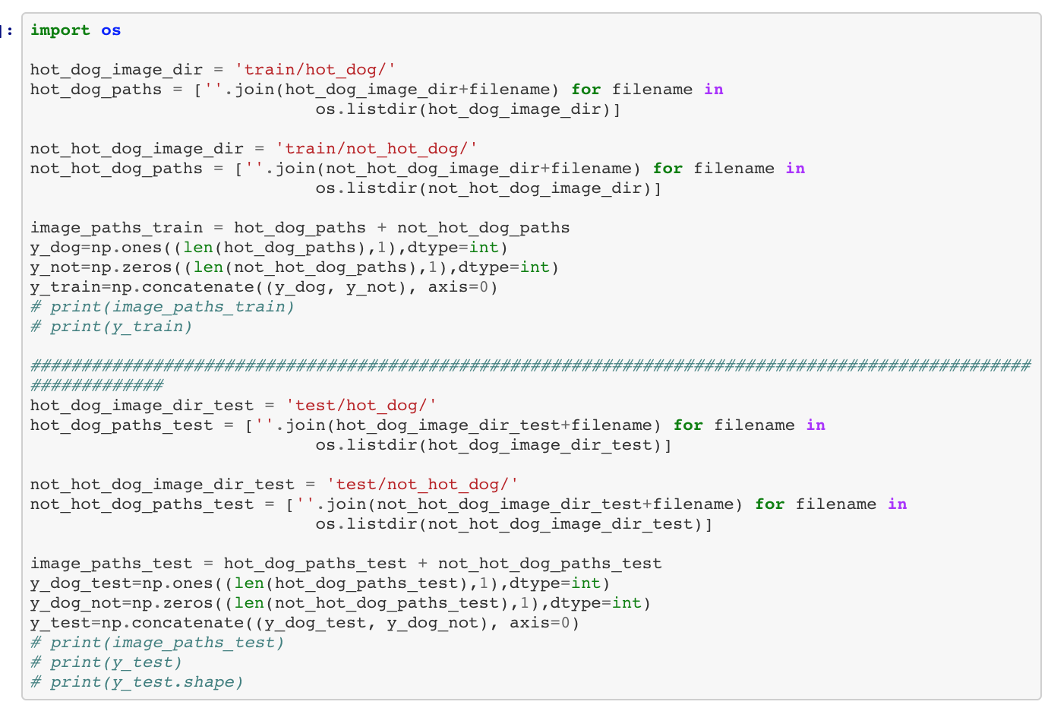

Each picture has exactly a given height and width pixel dimension, along with three layers that correspond to their respective red, blue and green color intensity. By utilizing the Keras.processing.image library, the data was split into three dimensions in the following order(width, height, depth):

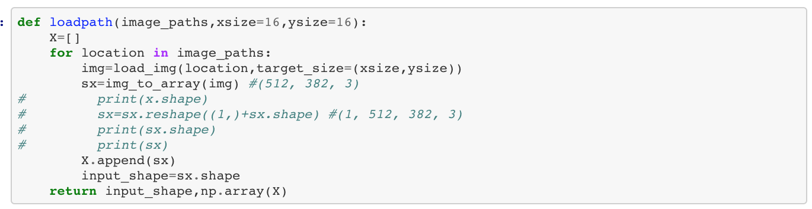

Thanks to the advances in science throughout the last new Centuries, there a library that generates entropy! By using the following code, the stimulating environment allows us to randomly split our datasets!

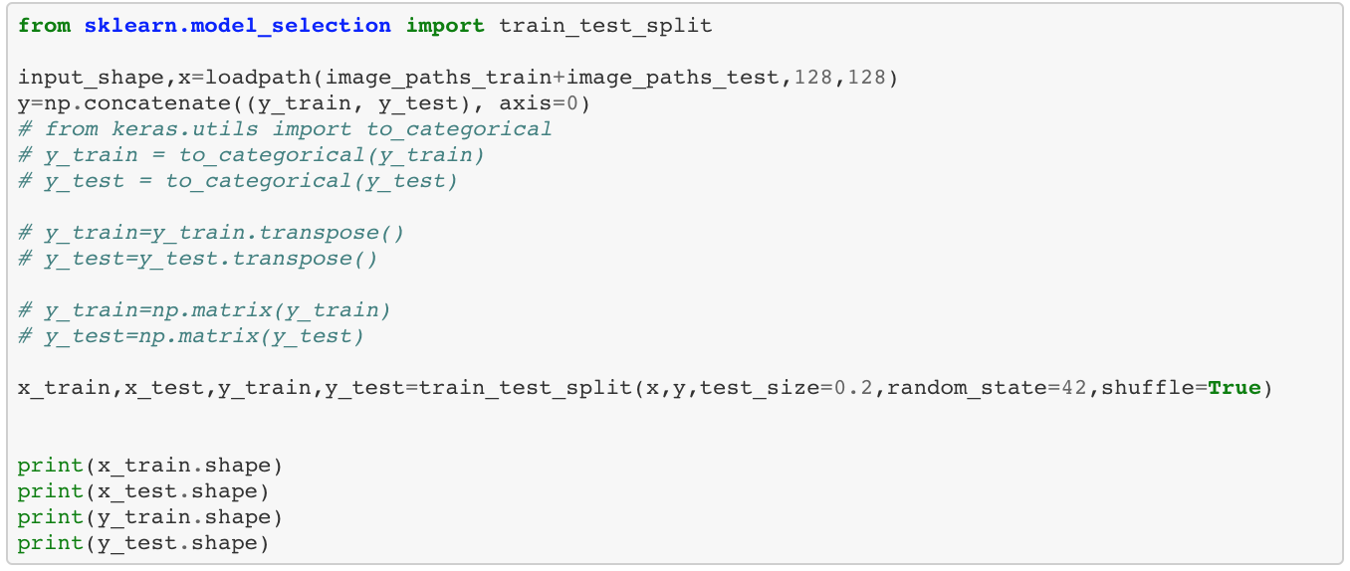

Models:

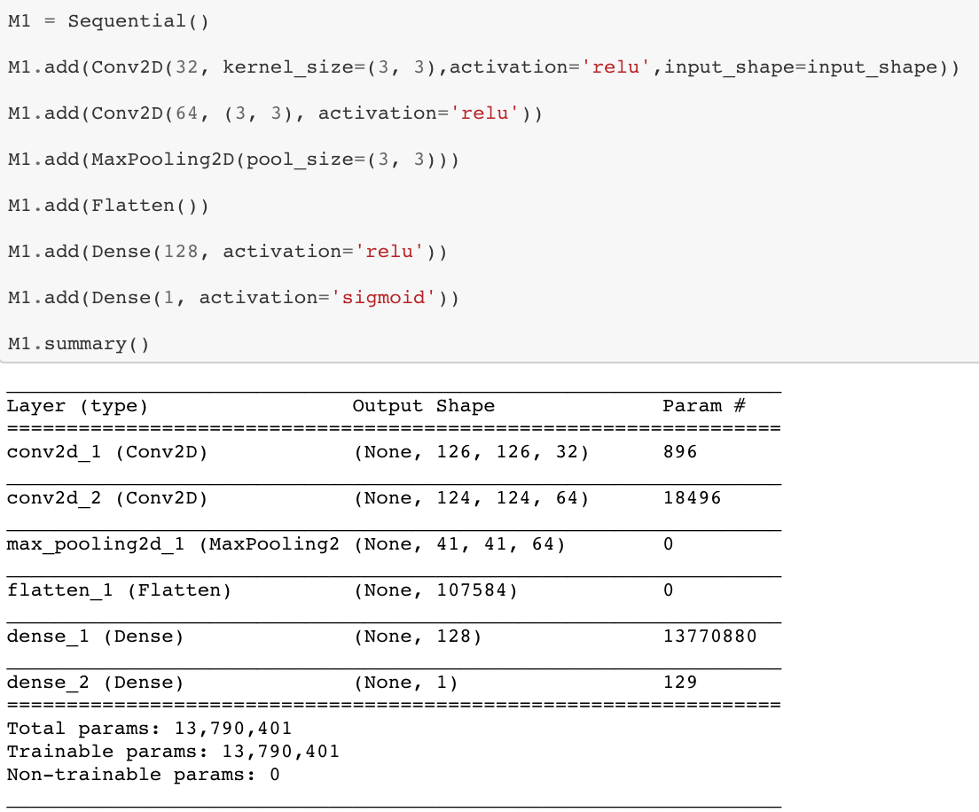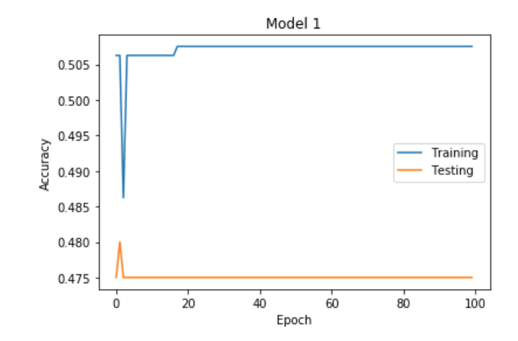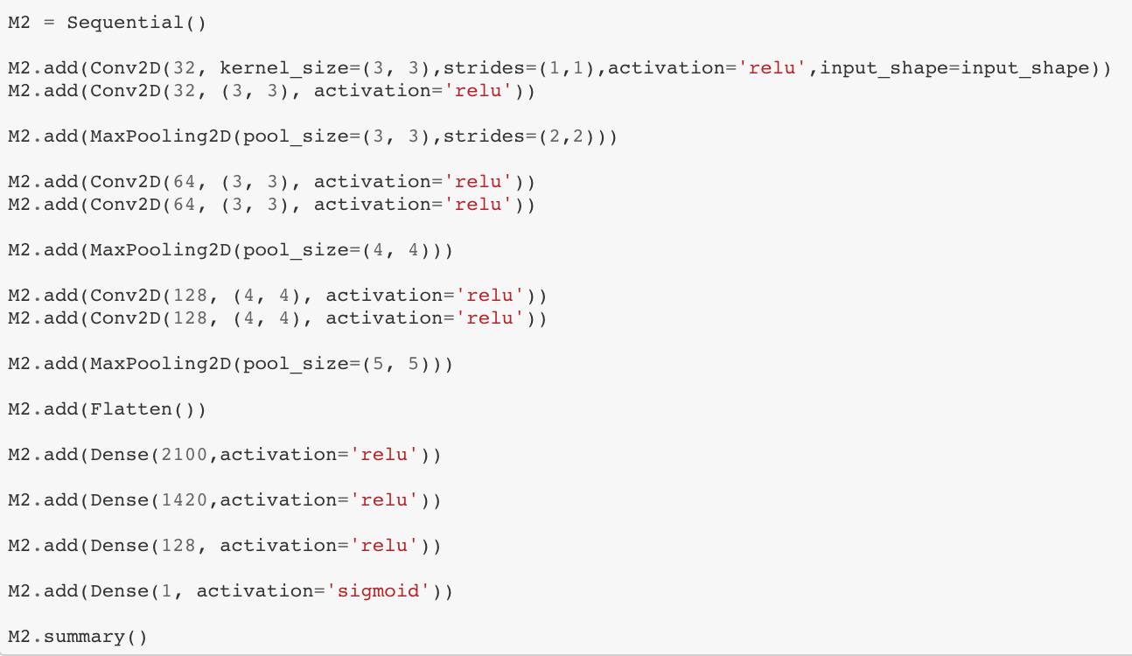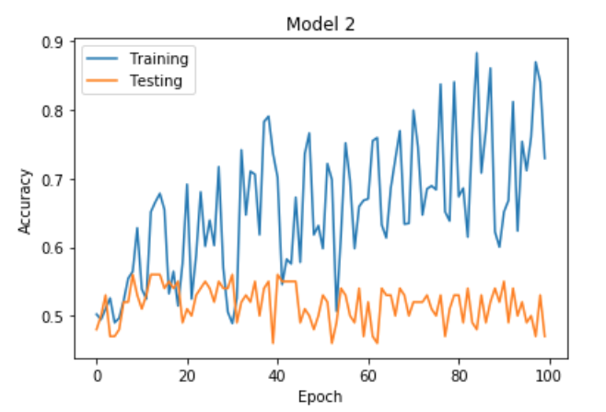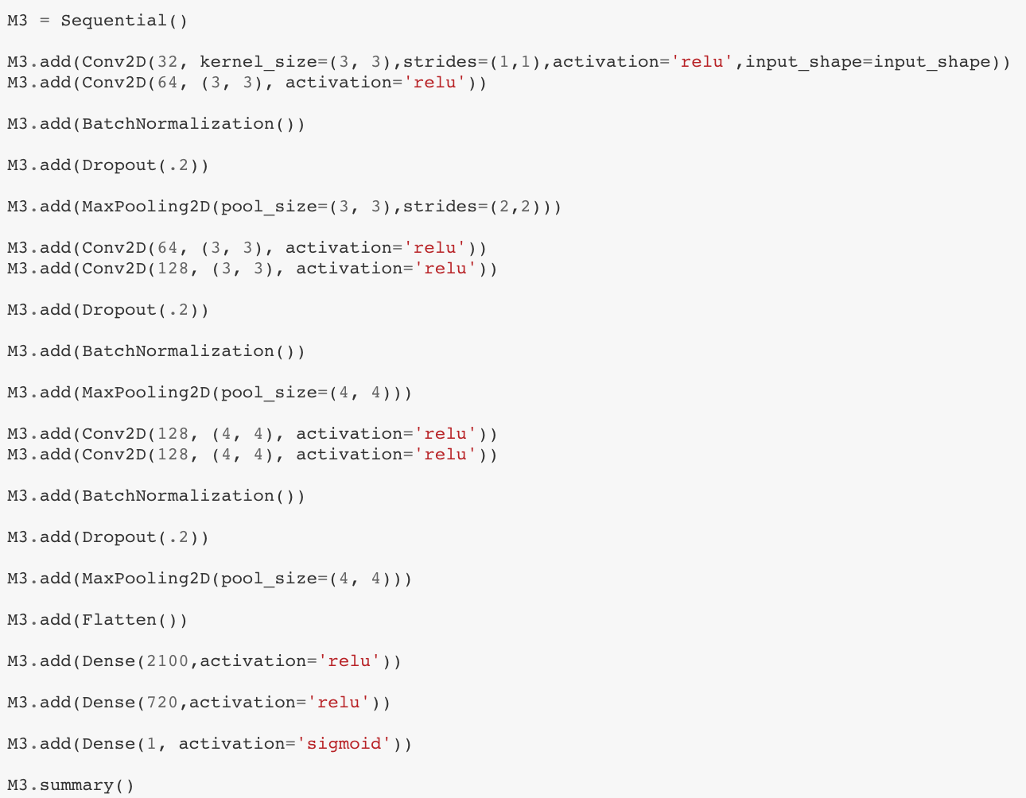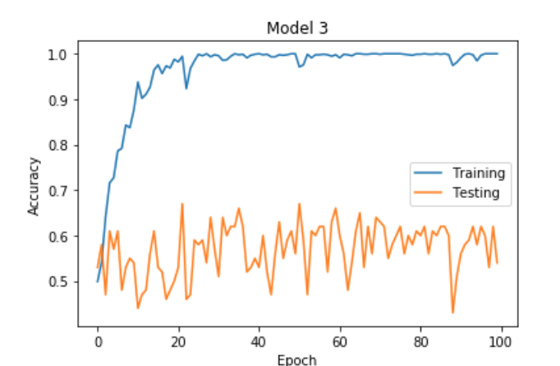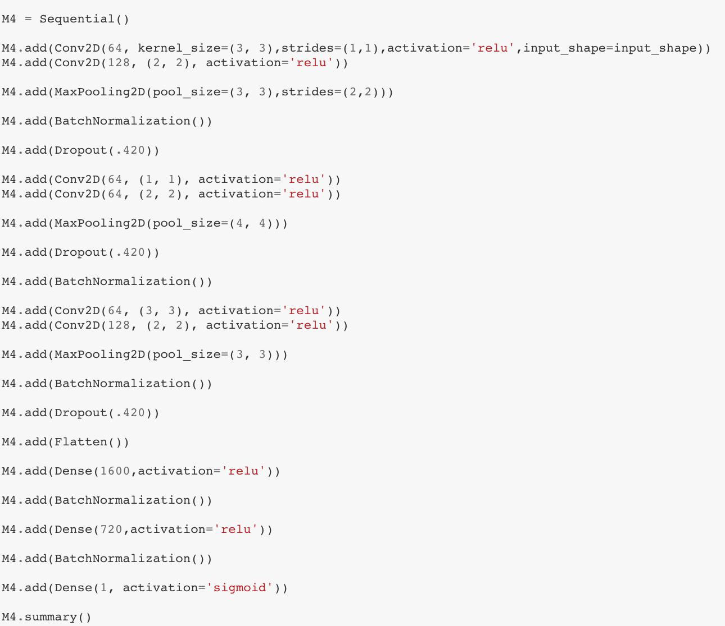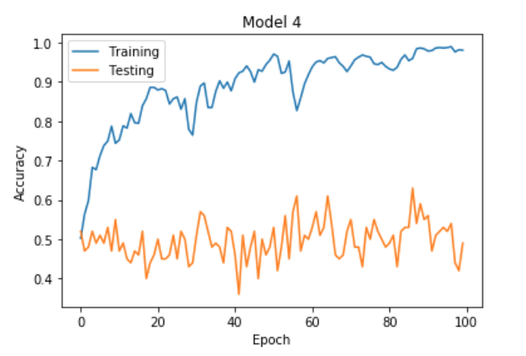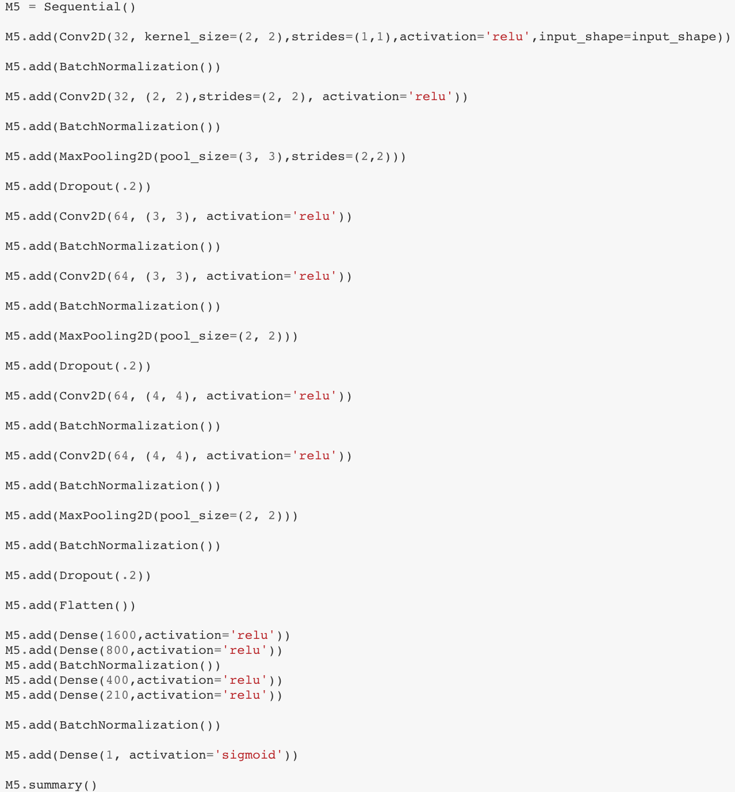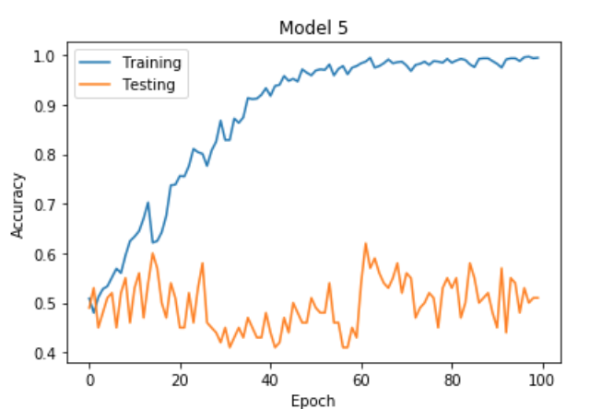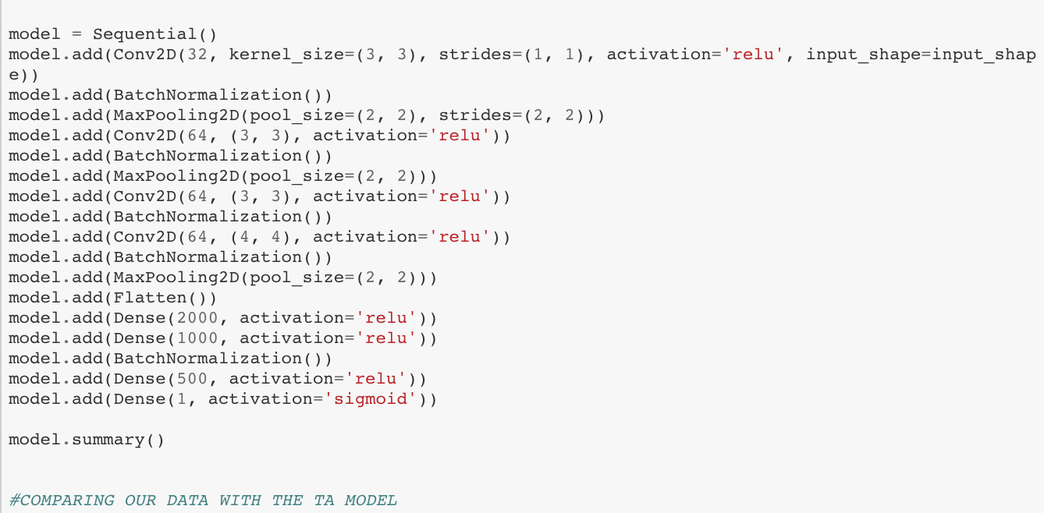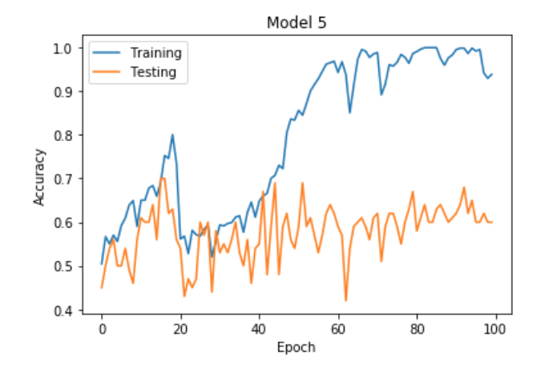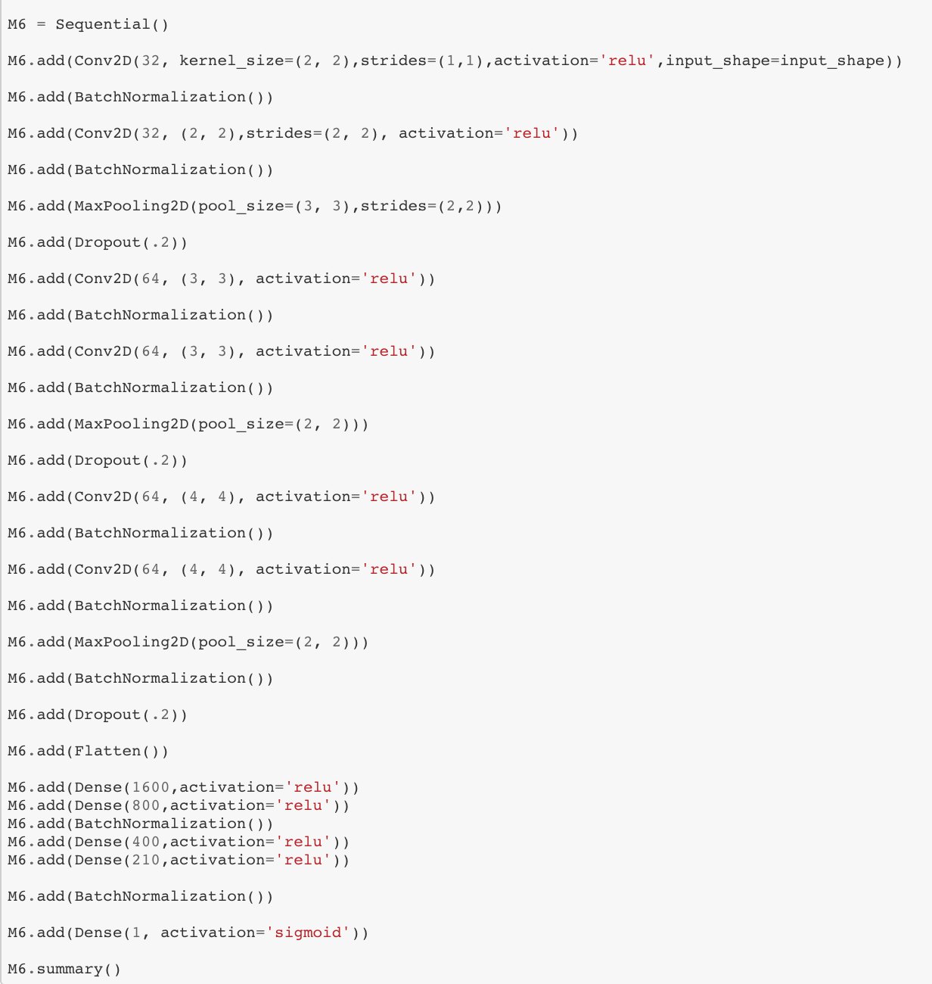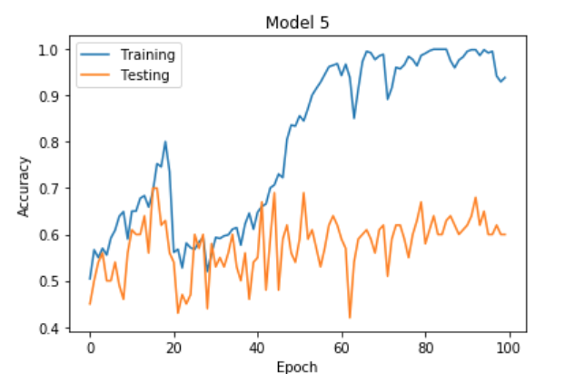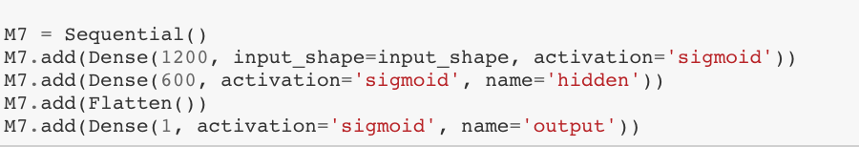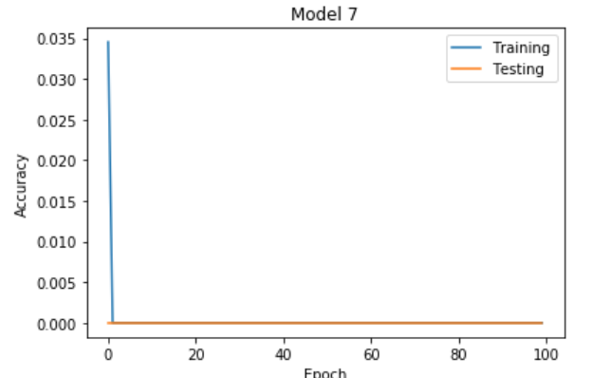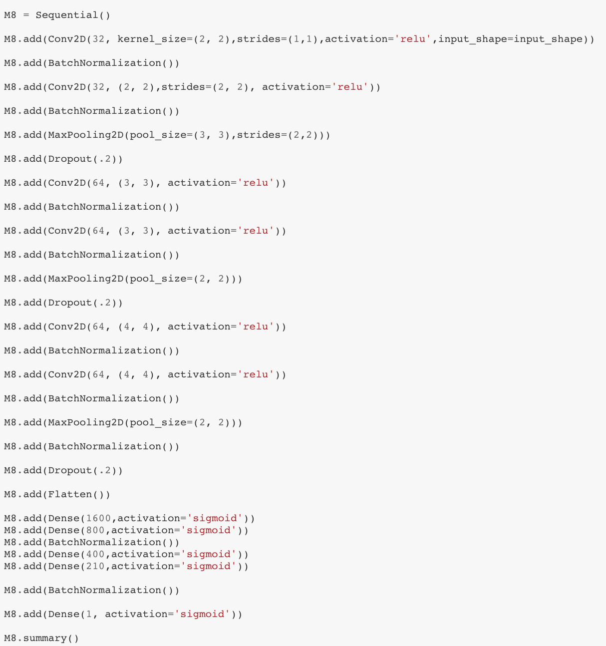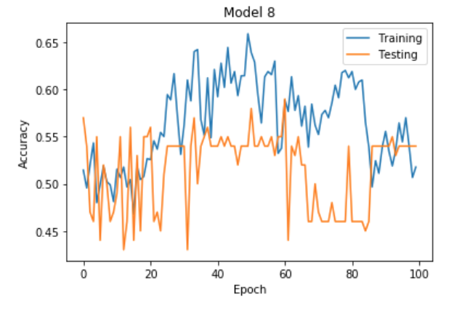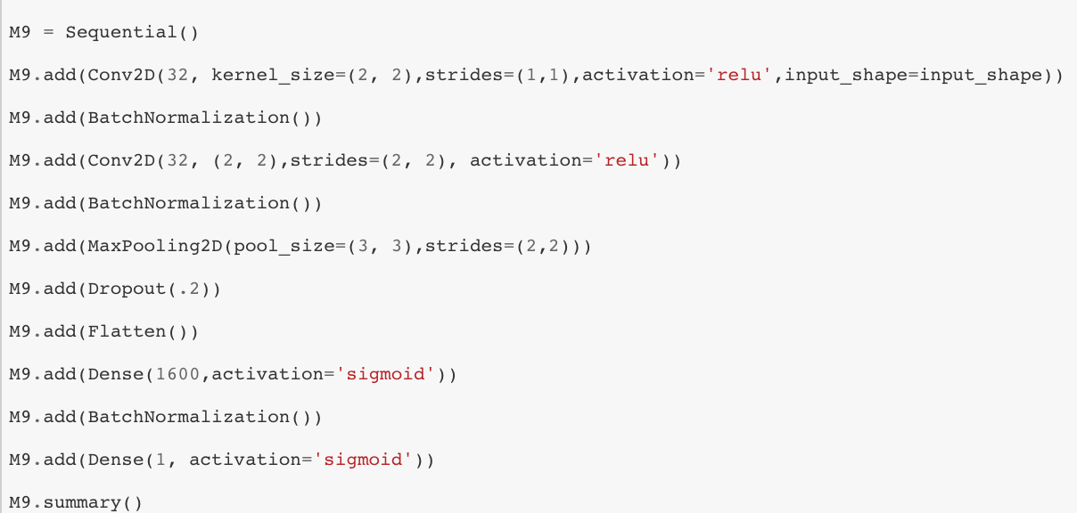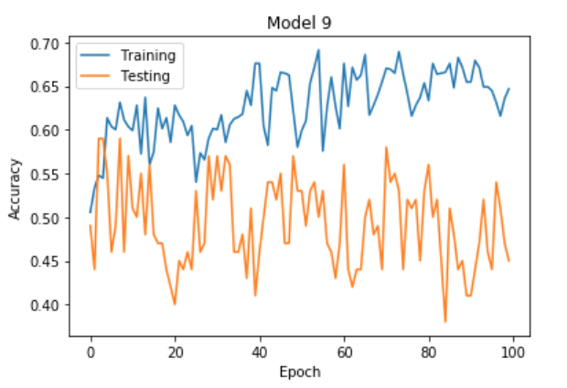

The Models created were based on trial and error. We begin at the beginning of Model1. Model1 was a complete beauty, but it was also an accident. We needed to have the loss function base on something that can separate the photos, but instead, we accidentally used mean square error. This renders, the data useless, but fear not. We will learn from our mistakes.

Model2 to Models8 were the the evolutionary steps that the neural networks evolved into. Model 2 began as an understanding of the non-linearity of the function relu. Relu is like the spaghetti of the glories day of the Roman Empire. The concept is insanely complete, but it’s rewards are so delicious. Without going indept, Relu is non-linear. This is why when you call upon a Convolutional 2D on it, you need to use it twice. For an example, let us get into facial recognition:

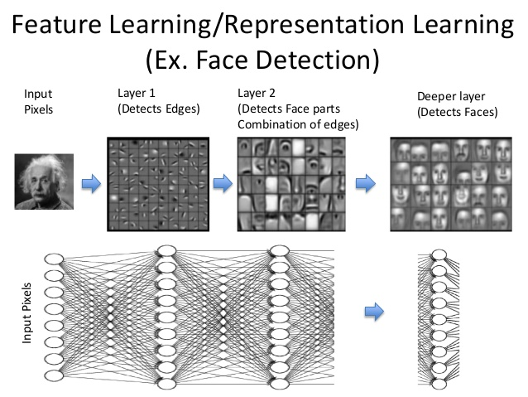

If the data was linear, then the formula would be y=w1*w2*w3*x. But because of the principle of Relu, you will need the equation to be reshaped to be around y=w3*max(0,w2*max(0, max(w1*x))). The advantage of using multiple layers is that it learns different representation at each layer. For example, a network that detects a human in an image, will learn edges in the first layer, shapes in the next, body parts in the next and finally humans in the last. This is precisely Model 2 was based upon. The ideology that by using two Convolutional 2D networks each time, you can gain maybe the left curve of the tip of the Hot-Dog and then zoomed out to see the tip of the Hot-Dog. The rest of models were based upon Model 2 with some changes of layering, pixel intensity, but a few were an exception.

Model here is what our glorious TA made in his dataset. The reason why his neural network is tested is so that we have a standard of measurement. It’s not to determine, whose network is better. However, according to our measurements, our networks did around the same his network. We will talk about how performance is measured later on.

Model 7 is where a whole new concept was introduced. Based on only the sigmoid method introduced in Mnst demo lab, we decided to build a neural network that’s only based on the sigmoid function. The results were astonishing because the accuracy of that model was exactly zero.

Model 8 to Model 9 was the evolutionary change that combined both the sigmoid and relu. The need for relu in Convolutional 2D and Max pool was effective, but diversity was missing from the neural network. That’s when the idea of introducing the sigmoid function after the need of relu was introduced. Model 8 took advance that surprised scholar Jin. By using the sigmoid function after the necessity of relu for Maxpooling and Convolutional 2D, the model worked relatively better. But in theory, it was amazing. Just image, after figuring out all the features, you plug it into the sigmoid function and an boolean is erected. It’s almost poetic.

*Measurements of success:*

The accuracy measurement that was used was binary_accuracy instead of the normal categlory_accuracy. Here’s the difference:

Binary_accuracy:

K.mean(K.equal(y_true, K.round(y_pred)))

Categlory_accuracy:

K.mean(K.equal(K.argmax(y_true, axis=-1), K.argmax(y_pred, axis=-1)))

***Conclusion:***

The model that was the most successful was a range between Model 6 and Model 8. However, the features that 100% defines what a Hot-Dog is,is still among the mist. The technology is close, but not there. The question still remains; What exactly makes a Hot-Dog a Hot-Dog?